**Figure S1**

Screenshot of the Tencent Questionnaire Platform

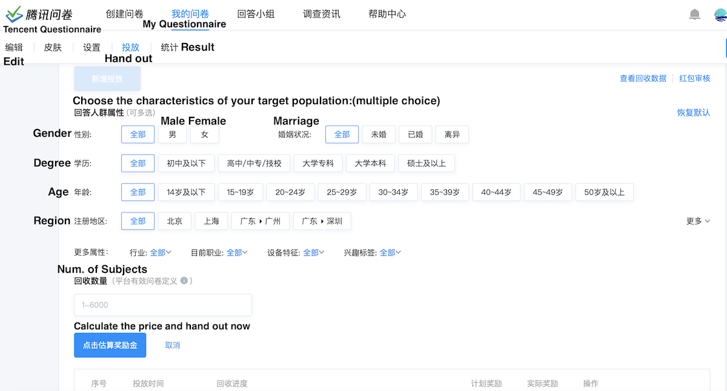

**Figure S2**

Structural equation modeling in CFA

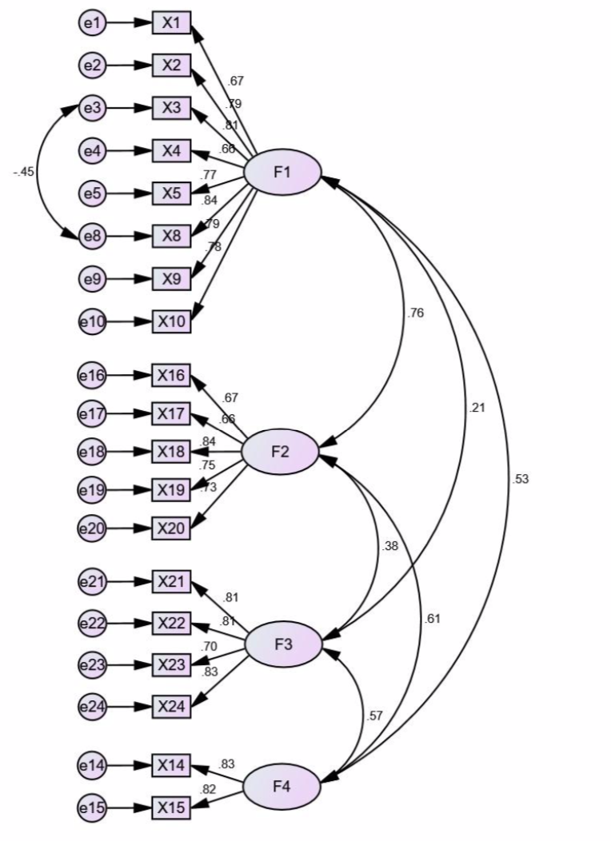

**Table S1**

Items collected and descriptions in the questionnaire

|  |  |
| --- | --- |
| **Item** | **Description** |
| X1 | Disinfecting the surrounding outdoors rarely touched by hands, such as the ground, plants, and walls, is an over-prevention behavior in the high- and low-risk regions (Pang, 2020). |
| X2 | Disinfecting clothes and soles by using alcohol and other disinfectants after getting home even without close contact with confirmed cases of infection is an over-prevention behavior in the high- and low-risk regions (Chinese Center for Disease Control and Prevention, 2020; Beijing Center for Disease Prevention and Control, 2020). |
| X3 | Using alcohol and other disinfectants to clean the house every day, even without patients living, is an over-prevention behavior in the high- and low-risk regions (Chinese Center for Disease Control and Prevention, 2020; Beijing Center for Disease Prevention and Control, 2020). |
| X4 | Using ultraviolet rays at home, even without patients living, is an over-prevention behavior in the high- and low-risk regions (Beijing Center for Disease Prevention and Control, 2020). |
| X5 | Using alcohol and other disinfectants to clean packages of carry-out, parcel, and shopping commodities is an over-prevention behavior in the high- and low-risk regions (Beijing Center for Disease Prevention and Control, 2020). |
| X6 | Using disinfectants (75% alcohol excepted) to clean hands every day even without close contact with infected cases is an over-prevention behavior in the high- and low-risk regions (Beijing Center for Disease Prevention and Control, 2020). |
| X7 | Using alcohol to clean used medical or N95 masks is an over-prevention behavior in the high- and low-risk regions (WHO, 2020). |
| X8 | Using converted mist cannon trucks and drones to spray disinfectants to the air outdoors is an over-prevention behavior exhibited by staff in the high- and low-risk regions (Pang, 2020; The National Health Commission of the People’s Republic of China, 2020). |
| X9 | Disinfecting wheels and surfaces of ordinary cars that did not carry patients is an over-prevention behavior exhibited by staff in the high- and low-risk regions (Pang, 2020; Beijing Center for Disease Prevention and Control, 2020). |
| X10 | Building disinfection shed at the gate of a community to clean people thoroughly who entered it is an over-prevention behavior exhibited by staff in the high- and low-risk regions (Pang, 2020; The National Health Commission of the People’s Republic of China, 2020). |
| X11 | Using high-concentration or large amounts of disinfectants to clean corridors in a community in non-focus of infection is an over-prevention behavior exhibited by staff in the high- and low-risk regions (Beijing Center for Disease Prevention and Control, 2020). |
| X12 | Using disinfectants to clean outdoors in a community in non-focus of infection is an over-prevention behavior exhibited by staff in the high- and low-risk regions (Beijing Center for Disease Prevention and Control, 2020; The National Health Commission of the People’s Republic of China, 2020). |
| X13 | Requiring people to disinfect their clothes and soles before entering public areas is an over-prevention behavior in the high- and low-risk regions (Beijing Center for Disease Prevention and Control, 2020; The National Health Commission of the People’s Republic of China, 2020). |
| X14 | Disinfecting the air outdoors on rainy and snowy days is an over-prevention behavior exhibited by staff in the high- and low-risk regions (The National Health Commission of the People’s Republic of China, 2020). |
| X15 | Casting disinfectants to lakes, reservoirs, and pools is an over-prevention behavior exhibited by staff in the high- and low-risk regions (The National Health Commission of the People’s Republic of China, 2020). |
| X16 | Wearing masks indoors, such as in an office, chamber, school, and other ventilated rooms, where people can remain one meter apart, is an over-prevention behavior in the low-risk regions (The National Health Commission of the People’s Republic of China, 2020). |
| X17 | Wearing masks in private cars without patients is an over-prevention behavior in the high- and low-risk regions (The National Health Commission of the People’s Republic of China, 2020). |
| X18 | Wearing masks outdoors where people can remain one meter apart is an over-prevention behavior in the high- and low-risk regions (The National Health Commission of the People’s Republic of China, 2020). |
| X19 | Enforcing people to wear masks indoors, such as in an office, chamber, school, and other ventilated rooms, where they can remain one meter apart, is an over-prevention behavior in the low-risk regions (The National Health Commission of the People’s Republic of China, 2020). |
| X20 | Inhibiting people to go outdoors without wearing masks is an over-prevention behavior in the high- and low-risk regions (The National Health Commission of the People’s Republic of China, 2020). |
| X21 | Restricting human rights violently by implementing preventive measures, such as breaking into houses and hitting people, is an over-prevention behavior in the high- and low-risk regions (WHO, 2016). |
| X22 | Setting pandemic checkpoints inappropriately, which harms human rights, such as the steel wire accidentally killing a passer-by reported in China, is an over-prevention behavior in the high- and low-risk regions (WHO, 2016). |
| X23 | Collecting private information frequently or forcing privacy disclosure is an over-prevention behavior in the high- and low-risk regions (Nay, 2020). |
| X24 | Damaging individual property rights as part of pandemic prevention, for instance, staff throwing away students’ items from the dormitory without permission to make room for patients that hospitals could not accommodate, is an over-prevention behavior in the high- and low-risk regions (WHO, 2016). |
| X25 | Isolating received parcels in the corner of the house for several days is an over-prevention behavior in the high- and low-risk regions (Beijing Center for Disease Prevention and Control, 2020). |
| X26 | Wearing gloves in public areas without the need to nurse patients or clean infected areas is an over-prevention behavior in the high- and low-risk regions (WHO, 2021). |
| X27 | Delaying the operation of some enterprises in places qualified to allow the opening of workplaces is an over-prevention behavior in the low-risk regions (Ministry of Housing and Urban-Rural Development of the People’s Republic of China, 2020). |

**Table S2**

Sample distribution in seven areas of China

|  |  |
| --- | --- |
| **Area (Provinces covered)** | **Sample size** |
| Northeast China (Heilongjiang, Jilin, and Liaoning) | 191 |
| North China (Beijing, Tianjin, Hebei, Shanxi, and Inner Mongolia) | 204 |
| East China (Shanghai, Jiangsu, Zhejiang, Anhui, Jiangxi, Shandong, Fujian, and Taiwan) | 215 |
| Central China (Henan, Hubei, and Hunan) | 179 |
| South China (Guangdong, Guangxi, Hainan, Hongkong, and Macau) | 170 |
| Southwest China (Chongqing, Sichuan, Guizhou, Yunnan, and Tibet) | 176 |
| Northwest China (Shaanxi, Gansu, Ningxia, Qinghai, and Sinkiang) | 185 |
| Total | 1320 |

**Table S3**

Characteristics of the remaining sample (*n* = 1320)

|  |  |
| --- | --- |
| **Variable** | **Value** |
| **Gender** |  |
| Male | 701 (53.1%) |
| Female | 619 (46.9%) |
| **Age** |  |
| 0–17 years | 19 (1.4%) |
| 18–29 years | 422 (32.0) |
| 30–39 years | 577 (43.7%) |
| 40–49 years | 235 (17.8%) |
| 50–59 years | 59 (4.5%) |
| 60 years and above | 8 (0.6%) |
| **Education degree** |  |
| Primary school and lower | 5 (0.4%) |
| Junior high school | 122 (9.2%) |
| Senior high school | 235 (17.8%) |
| College degree | 876 (66.4%) |
| Postgraduate degree and higher | 82 (6.2%) |
| **Employment status** |  |
| Student | 292 (22.1%) |
| Staff in an enterprise | 397 (30.1%) |
| Staff in an institution (science, education, culture, health, and other institutions) | 236 (17.9%) |
| Staff in governmental an agency | 50 (3.8%) |
| Self-employed | 197 (14.9%) |
| Others (including retirement) | 148 (11.2%) |

**Table S4**

Rotated component matrix and communalities

|  |  |  |  |  |  |
| --- | --- | --- | --- | --- | --- |
| **Item** | **Factor loading** | | | | **Communality** |
| **Factor 1** | **Factor 2** | **Factor 3** | **Factor 4** |
| X1 | 0.744 |  |  |  | 0.572 |
| X2 | 0.831 |  |  |  | 0.731 |
| X3 | 0.781 |  |  |  | 0.682 |
| X4 | 0.538 |  |  |  | 0.463 |
| X5 | 0.798 |  |  |  | 0.714 |
| X8 | 0.719 |  |  |  | 0.674 |
| X9 | 0.682 |  |  |  | 0.652 |
| X10 | 0.655 |  |  |  | 0.650 |
| X14 |  |  |  | 0.758 | 0.753 |
| X15 |  |  |  | 0.832 | 0.785 |
| X16 |  | 0.790 |  |  | 0.672 |
| X17 |  | 0.591 |  |  | 0.555 |
| X18 |  | 0.767 |  |  | 0.772 |
| X19 |  | 0.826 |  |  | 0.747 |
| X20 |  | 0.637 |  |  | 0.615 |
| X21 |  |  | 0.825 |  | 0.704 |
| X22 |  |  | 0.882 |  | 0.787 |
| X23 |  |  | 0.800 |  | 0.683 |
| X24 |  |  | 0.872 |  | 0.789 |

**Table S5**

Final weights of each item based on PCA

|  |  |  |  |
| --- | --- | --- | --- |
| **Item** | **Weight** | **Item** | **Weight** |
| X1 | 0.068 | X16 | 0.044 |
| X2 | 0.066 | X17 | 0.041 |
| X3 | 0.055 | X18 | 0.041 |
| X4 | 0.052 | X19 | 0.037 |
| X5 | 0.068 | X20 | 0.045 |
| X8 | 0.065 | X21 | 0.043 |
| X9 | 0.062 | X22 | 0.038 |
| X10 | 0.058 | X23 | 0.036 |
| X14 | 0.062 | X24 | 0.040 |
| X15 | 0.081 | Total | 1 |

**Table S6**

Loadings of each item and AVE and CR tested

|  |  |  |  |  |  |
| --- | --- | --- | --- | --- | --- |
| **Item** | **Path** | **Factor** | **Loading** | **AVE** | **CR** |
| X1 | <--- | Factor 1 | 0.673 | 0.587 | 0.919 |
| X2 | <--- | Factor 1 | 0.788 |
| X3 | <--- | Factor 1 | 0.812 |
| X4 | <--- | Factor 1 | 0.664 |
| X5 | <--- | Factor 1 | 0.765 |
| X8 | <--- | Factor 1 | 0.842 |
| X9 | <--- | Factor 1 | 0.790 |
| X10 | <--- | Factor 1 | 0.775 |
| X16 | <--- | Factor 2 | 0.672 | 0.535 | 0.851 |
| X17 | <--- | Factor 2 | 0.655 |
| X18 | <--- | Factor 2 | 0.835 |
| X19 | <--- | Factor 2 | 0.750 |
| X20 | <--- | Factor 2 | 0.730 |
| X21 | <--- | Factor 3 | 0.814 | 0.625 | 0.869 |
| X22 | <--- | Factor 3 | 0.814 |
| X23 | <--- | Factor 3 | 0.696 |
| X24 | <--- | Factor 3 | 0.830 |
| X14 | <--- | Factor 4 | 0.833 | 0.684 | 0.812 |
| X15 | <--- | Factor 4 | 0.821 |

**Table S7**

Correlation coefficients and AVE

|  |  |  |  |  |
| --- | --- | --- | --- | --- |
| **Factor** | **Factor 1** | **Factor 2** | **Factor 3** | **Factor 4** |
| Factor 1 | 0.587a |  |  |  |
| Factor 2 | 0.759c | 0.535a |  |  |
| Factor 3 | 0.213b | 0.383c | 0.625a |  |
| Factor 4 | 0.532c | 0.612c | 0.567c | 0.684a |
| Sqrt(AVE) | 0.766 | 0.731 | 0.791 | 0.827 |

aWe listed the AVE of each factor diagonally. The last row was the square root.

b*P* < 0.01.

c*P* < 0.001.

**Table S8**

χ2 test between attitude and personal information variables (*n* = 1320)

|  |  |  |  |  |  |  |  |  |
| --- | --- | --- | --- | --- | --- | --- | --- | --- |
|  | **F1** | | **F2** | | **F3** | | **F4** | |
|  | **Agree** | **Disagree** | **Agree** | **Disagree** | **Agree** | **Disagree** | **Agree** | **Disagree** |
| **Gender** |  |  |  |  |  |  |  |  |
| Male | 384 | 317 | 373 | 328 | 361 | 340 | 334 | 367 |
| Female | 289 | 330 | 304 | 315 | 305 | 314 | 310 | 309 |
| χ2 | 8.611b |  | 2.210 |  | 0.651 |  | 0.780 |  |
| **Age** |  |  |  |  |  |  |  |  |
| 0–17 years | 11 | 8 | 10 | 9 | 6 | 13 | 7 | 12 |
| 18–29 years | 178 | 244 | 253 | 169 | 241 | 181 | 204 | 218 |
| 30–39 years | 306 | 271 | 279 | 298 | 275 | 302 | 281 | 296 |
| 40–49 years | 140 | 95 | 110 | 125 | 112 | 123 | 116 | 119 |
| 50–59 years | 32 | 27 | 21 | 38 | 30 | 29 | 31 | 28 |
| 60 years and above | 6 | 2 | 4 | 4 | 2 | 6 | 5 | 3 |
| χ2 | 23.457c | | 22.394c | | 14.797a | | 2.087 |  |
| **Area of China** |  |  |  |  |  |  |  |  |
| Northeast | 104 | 87 | 86 | 105 | 89 | 102 | 85 | 106 |
| North | 103 | 101 | 100 | 104 | 91 | 113 | 102 | 102 |
| East | 113 | 102 | 122 | 93 | 117 | 98 | 115 | 100 |
| Central | 78 | 101 | 100 | 79 | 82 | 97 | 86 | 93 |
| South | 78 | 92 | 83 | 87 | 98 | 72 | 73 | 97 |
| Southwest | 92 | 84 | 88 | 88 | 93 | 83 | 94 | 82 |
| Northwest | 105 | 80 | 98 | 87 | 96 | 89 | 89 | 96 |
| χ2 | 9.437 |  | 8.222 |  | 10.895 |  | 7.329 |  |
| **Employment** |  |  |  |  |  |  |  |  |
| Student | 111 | 181 | 189 | 103 | 155 | 137 | 138 | 154 |
| In an enterprise | 214 | 183 | 209 | 188 | 197 | 200 | 197 | 200 |
| Inan institution | 27 | 23 | 29 | 21 | 27 | 23 | 28 | 22 |
| In a governmental agency | 140 | 96 | 96 | 140 | 112 | 124 | 112 | 124 |
| Self-employed | 104 | 93 | 89 | 108 | 108 | 89 | 87 | 110 |
| Others | 77 | 71 | 65 | 83 | 67 | 81 | 82 | 66 |
| χ2 | 28.081c | | 39.095c | | 5.111 |  | 5.872 |  |
| **Education Degree** | | |  |  |  |  |  |  |
| Primary and lower | 2 | 3 | 1 | 4 | 3 | 2 | 3 | 2 |
| Junior high school | 63 | 59 | 42 | 80 | 62 | 60 | 60 | 62 |
| Senior high school | 129 | 106 | 106 | 129 | 117 | 118 | 124 | 111 |
| College degree | 432 | 444 | 467 | 409 | 447 | 429 | 414 | 462 |
| Postgraduate degree and higher | 47 | 35 | 61 | 21 | 37 | 45 | 43 | 39 |
| χ2 | 3.992 |  | 38.389c | | 1.278 |  | 3.003 |  |

a*P* < 0.05, b*P* < 0.01, and c*P* < 0.001. These figures are the number of cases in groups with different characteristics, followed by the Pearson χ2 test in the last row.

**Table S9**

Logistic regression results (*n* = 1320)

|  |  |  |  |  |  |  |  |  |
| --- | --- | --- | --- | --- | --- | --- | --- | --- |
|  | **F1** | | **F2** | | **F3** | | **F4** | |
|  | **Beta** | ***OR***  **(95% CI)** | **Beta** | ***OR***  **(95% CI)** | **Beta** | ***OR***  **(95% CI)** | **Beta** | ***OR***  **(95% CI)** |
| **Gender** | −0.294a | 0.745  (0.596, 0.931) |  |  |  |  |  |  |
| **Age** |  |  |  |  | −0.128a | 0.880  (0.778, 0.994) |  |  |
| **Area of China (0)** |  |  |  |  |  |  |  |  |
| **Area of China (1)** |  |  |  |  |  |  |  |  |
| **Area of China (2)** |  |  |  |  |  |  |  |  |
| **Area of China (3)** |  |  |  |  |  |  |  |  |
| **Area of China (4)** |  |  |  |  |  |  |  |  |
| **Area of China (5)** |  |  |  |  |  |  |  |  |
| **Area of China (6)** |  |  |  |  |  |  |  |  |
| **Employment (0)** | —c |  | —c |  |  |  |  |  |
| **Employment (1)** | 0.594c | 1.811  (1.328, 2.472) | −0.467b | 0.627  (0.459, 0.857) |  | |  |  |
| **Employment (2)** | 0.585 | 1.796  (0.978, 3.296) | −0.360 | 0.698  (0.377, 1.291) |  |  |  |  |
| **Employment (3)** | 0.855c | 2.352  (1.654, 3.345) | −0.963c | 0.382  (0.267, 0.546) |  |  |  |  |
| **Employment (4)** | 0.580b | 1.786  (1.237, 2.579) | −0.526b | 0.591  (0.401, 0.871) |  |  |  |  |
| **Employment (5)** | 0.591b | 1.806  (1.209, 2.697) | −0.468a | 0.626  (0.405, 0.967) |  |  |  |  |
| **Education Degree** |  |  | 0.430c | 1.537  (1.294, 1.826) |  |  |  |  |

a*P* < 0.05, b*P* < 0.01, and c*P* < 0.001. The variables followed by a number in a bracket are the dummy variables. Considering the student group, we coded Employment (0) to Employment (5) into 00000 to 00001, varying from student to others, respectively. We did not observe any significant result in Employment (2) in F1 and F2. The dummy variable of Staff in institutions showed a lesser significant result than the dummy variable of Student.